Lexcel Matters
Summer Edition 2020
Hello Everyone, this year has been traumatic for many individuals and businesses, but I am glad to say that some light appears to be shining at the end of the tunnel. We are not out of the woods just yet but signs are promising.

Many lessons have been learnt during lockdown and new innovative processes developed and we are pleased to say that our approach to conducting remote reviews is one of them and has been a resounding success, with many firms complementing us and our assessor team for making the review seamless and extremely flexible. If you would like sight of our free Remote Review Webinar contact Marian.moir@recognisingexcellence.co.uk

For many firms trying to get back to the new normal, it will not be easy, and we at Recognising Excellence appreciate the challenges that you face. To try and help you as much as we can this edition of Lexcel Matters will focus on signposting you to help with your recovery.

For instance, control over finances is paramount to your survival that is why we have included the following item:

The Financial Stability Scorecard

The Lexcel Standard requires that practices must be able to document evidence of their financial management procedure and in addition, the SRA Code of Conduct (2.4) mandates for law firms to actively monitor their financial stability and viability.

Ongoing challenges to the macro-economic environment has seen legal sector commentators predict a large failure rate in law firms (60%) due to lack of cash. This prediction causes concern for insurers and lenders, so much so that they now look to tighten acceptance criteria which may preclude some firms from obtaining PII Insurance or the means to pay for it.

To help firms respond to these concerns a unique tool has been created which aims to help legal practices evidence their approach to financial management.

The Financial Stability Scorecard, developed by Gemstone Legal, provides an insight into the financial culture of the business. The finding can be used to discuss with insurers/lenders about the steps taken to promote financial stability. Alternatively, the scorecard will provide an indication of steps firms can take to improve their financial outlook.

The scorecard takes 5 minutes to complete, is free of charge and could help the firm to formulate strategic plans addressing items contained within Lexcel Section 1, 2, and 7 and as such firms may wish to evidence their approach via this link:
https://www.gemstonelegal.co.uk/financialstabilityscorecard

With an emphasis on the here-and-now needs of the legal sector, Recognising Excellence has teamed up with PDA who have a wealth of tools and resources to help you to manage risk, compliance and growth.
Free Training videos, webinars and podcasts plus downloadable PDF checklists for post-COVID management, GDPR and cybersecurity

Checklist for post-COVID regrowth  This lauded checklist provides checkpoints for consideration under the topic headings of ‘business systems’ and ‘people’.  It also touches upon sections 1 to 7 of the Lexcel standard. | Data protection checklist / questionnaire  Data protection are being sorely tested, right now, including influxes of Subject Access Requests from clients and staff.  A ‘barometer’ of your data protection status. |  | Cybersecurity checklist / questionnaire (and report)  Protecting information is high on the agenda, especially with many staff working from home.  An overview of your current cyber security status (including your readiness for Cyber Essentials).
Click here to download | Click here to download |  | Click here to download
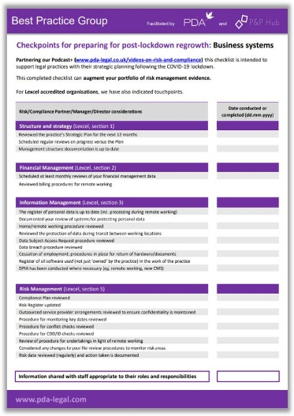 | 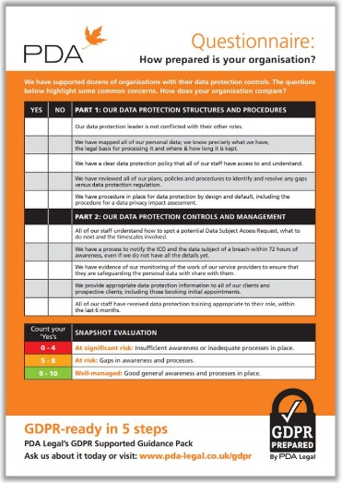 |  | 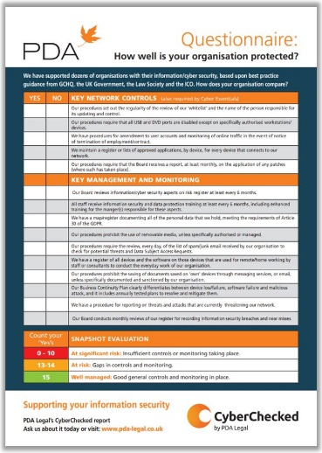
Articles on risk and compliance; for insight and staff training

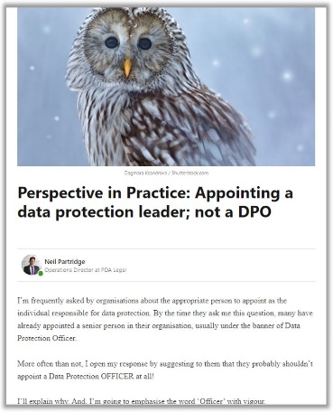 |  | 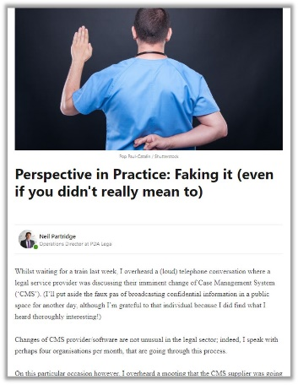 |  | 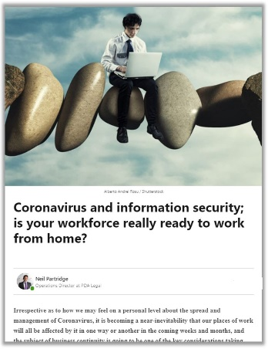
We are told by practices that like our videos, these are often used for staff training or to support compliance management. Click here to visit our library of articles

Best Practice Group (BPG)

We launched the ‘BPG’ in response to the (massive) demand for updates, guidance and insight on best practice, risk management, regulatory compliance, ‘opportunity’ and of course, Lexcel.

We hold free sessions across the UK. Seats for previous sessions were filled within hours by Lexcel and non-Lexcel firms. Feedback from the sessions has been nothing short of amazing!

We are delighted now, to throw open the doors of our Best Practice Group to welcome more legal practices from all over the UK. Priority will be given to firms associated with Recognising Excellence Click here to watch a (short) video to find out more.
Or, click here to download a PDF information sheet on the Best Practice Group.
Or, email BPG co-Founder Neil Partridge at neilp@pdalimited.com
 |  | **********************

Lexcel Snippets – a few snippets taken from recent Lexcel Assessors reports which you might be interested in:
- A website has been setup by a former Microsoft founder, which allows you to check if your email address and password has been compromised in a breach. Here’s an article about it and others that might be worth checking for your email addresses https://www.digitaltrends.com/computing/best-websites-for-finding-out-if-youve-been-hacked/
- The firm may wish to consider additional training for e.g the criminal defence team in relation to disability awareness. The Equality & Human Rights Commission has called for Codes of Conduct to be amended to make disability awareness a professional requirement and the evidence suggests that hidden disabilities are often overlooked e.g research suggests that half of the prison population may have sustained a traumatic brain injury at some stage, 40% have a mental health condition and between 5-10% have a learning disability
- There is an array of online tools to support self-development, a bonus of the current pandemic is a lot are now being offered at a lower price or even free. Online courses, apps, TED talks, podcasts and You Tube videos are growing in popularity:
Mary Portas - Podcast http://www.maryportas.com/podcast
Ted Talks https://www.ted.com/talks
Simon Sinek’s ‘Why/Finding your Purpose’ https://startwithwhy.com/about/#simon-sinek and ‘Millennials in the Workplace’ https://www.youtube.com/watch?v=hER0Qp6QJNU
James Kerr ‘Legacy,’ https://www.youtube.com/watch?v=KKvzExoH2Gg
Damian Hughes ‘The Barcelona Way’ https://www.amazon.com/Barcelona-Way-Create-High-performance-Culture-ebook/dp/B079RJSJC4
Mindtools https://www.mindtools.com
- Now may also be the time to consider the wellbeing and mental health of the firm’s staff, again there are a plethora of online tools, more now than ever, however the following come with recommendations from other firms the assessor has worked with:
- St John Ambulance 2 day course:
http://www.sja.org.uk/sja/training-courses/mental-health-first-aid/mental-health-first-aider.aspx?gclid=Cj0KCQjw2efrBRD3ARIsAEnt0ehRFMl6D3MFX8xao7cOFo7tmIctF6fhAvCCnQmfOb505becOUjV9qkaAn0PEALw_wcB
- Red Cross: https://www.redcrossfirstaidtraining.co.uk/what-we-do/mental-wellbeing-courses/
- Consider the free online tool run by the National Cyber Security Centre (part of GCHQ) aimed at small and medium sized businesses to help them assess the state of the cyber security. For details visit: https://www.ncsc.gov.uk/information/exercise-in-a-box
- Along with working paperless, your staff have also gained a lot of experience using MS Teams, Zoom etc as part of the tribunals, attendances and hearings that they would hitherto have been at in person along with counsel, doctors, magistrates and other experts. Again, it is quite possible that this world will have changed irreversibly and that some of these meetings will continue to be held virtually in the future. If that is the case, then you may wish to encourage staff to share any strategies or approaches that they have adopted to help in the virtual environment in terms of what one might need to do, for example, to get ones point across without having access to the full range of gestural and nonverbal vocabulary that one can employ in a real meeting with everyone physically present. This sort of learning could also be very helpful in terms of working with counsel etc who must themselves have found challenges in operating in a virtual forum.
*********
If you would like a no obligations quote for your next review why not give us a call, after all you could save your firm a lot of money. To non-accredited firms who would like to know more about Lexcel or are interested in a free of charge visit to discuss becoming Lexcel accredited please call John Edwards on 07771 988427 or email: john.edwards@recognisingexcellence.co.uk and he will arrange for an accredited Lexcel Assessor to contact you to help move you forward. Additionally, ask for a copy of our free Lexcel assessment webinar to find out more about the process.
Finally, on behalf of all of us here at Recognising Excellence I would just like to add stay safe and if you think we can help you in any way just get in touch.

